Player moves using WS for forwards and backwards and AD for rotating left and right respectively.

These movements are done by directly manipulating the player’s position/orientation and do not use forces/torque.

Pressing Space allows the player to jump. This uses a force for movement.

This combined with pressing G to toggle gravity allowing the player to cheat and fly to progress over obstacles. Gravity is on when a red G is present in the bottom left corner.

It is still possible to disable camera movement and select objects in the world using Q to toggle. Then the keys U, Y, J and K can be present to view which objects are the nearest on the X and Z axes.

The following collisions exist in the game:

* Sphere/Sphere
* Sphere/AABB
* AABB/AABB
* Capsule/Sphere
* Capsule/AABB
* Capsule/Capsule

While capsule are in the game, no toque seems to be applied to them on collision, which makes me think torque is applied at the centre of mass and not the collision point.

The player uses a sphere collider, human AI use capsule colliders while destructible objects use collision volumes appropriate to their shape (e.g. sphere for spheres, AABB for cubes, capsule for capsules).

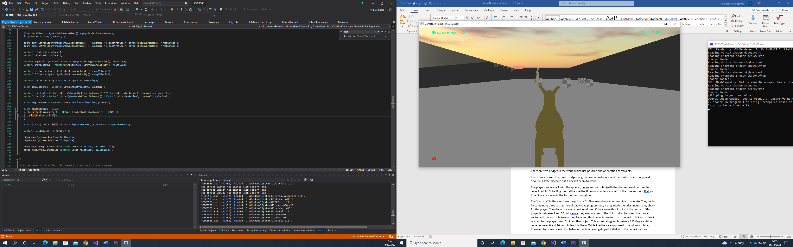

The game uses a quad tree.

Raycasts are used to determine when the player is grounded for jumping. The AI also uses a Raycast to determine if it has direct line of sight with the player or not. Given that the player is within a certain distance of the “human” AI.

Collision resolution is carried out using the method we were given Projection/Impulse.

There are two bridges in the world which use position and orientation constraints.

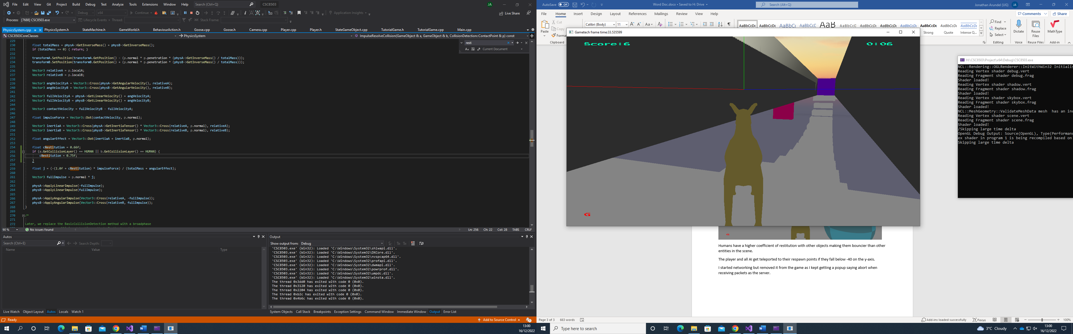

There is also a weird carousel bridge thing that uses constraints, and the central axle is supposed to also use a state machine which makes it rotate but it doesn’t seem to work.

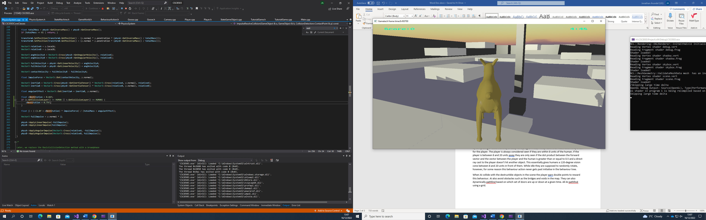

The player can interact with the spheres, cubes and capsules (with the checkerboard texture) to collect points. Collecting them all before the time runs out lets you win. If the time runs out first you lose. Score is shown in the top corner throughout.

There are coloured checkerboard spheres submerged in the floor which act as buttons to flip which colour doors are up and which are down. When the purple doors are up, the magenta ones are down and vice versa. The buttons are implemented like Unity’s “is Trigger” volumes, this means the player doesn’t collide and bounce off the button, instead it passes through it but the OnCollisionBegin/End functions are still called.

The “humans” in the world are the primary AI. They use a behaviour machine to operate. They begin by completing a route that they already have programmed, if they reach their destination they check for the player. The player is always considered seen if they are within 8 units of the human. If the player is between 8 and 20 units away they are only seen if the dot product between the forward vector and the vector between the player and the human is greater than or equal to 0.5 and a direct ray cast to the player doesn’t hit another object. This essentially gives humans a 120-degree vision cone between 8 and 20 units in front of them. While idle they are supposed to randomly rotate, however, for some reason this behaviour action never gets past initialise in the behaviour tree.

When AI collide with the destructible objects in the scene the player earn double points to reward this behaviour. AI also avoid obstacles such as the bridges and voids in the map. They can also dynamically pathfind based on which set of doors are up or down at a given time. All AI pathfind using a grid.

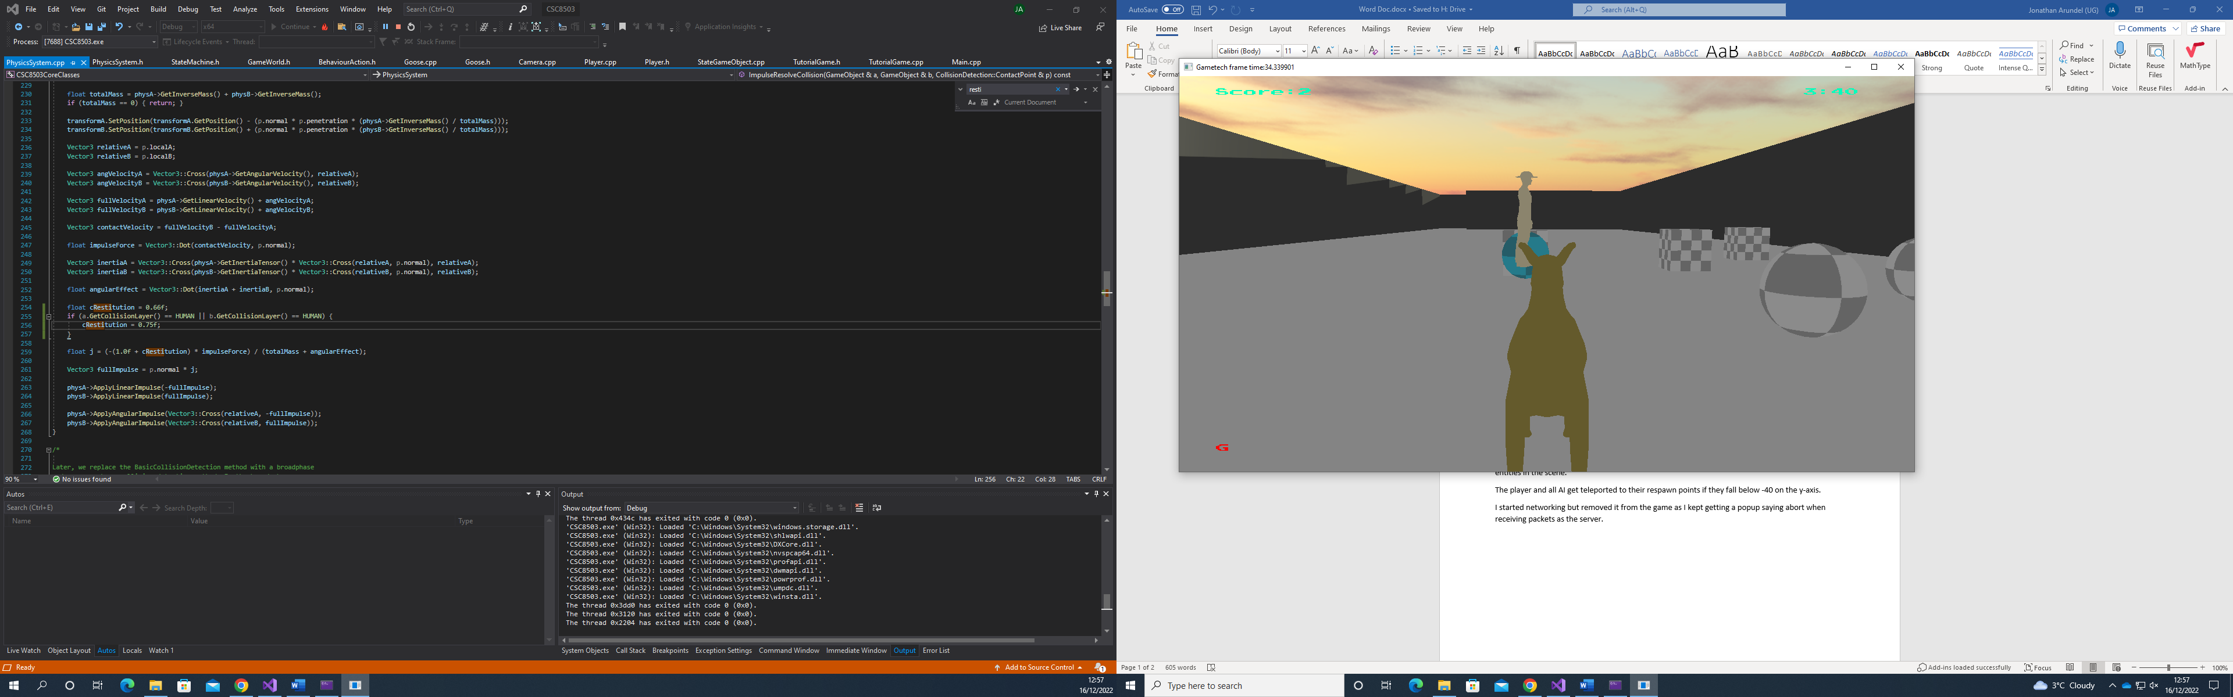

Destroyed objects get turned blue and their transparency is progressively increased over a couple of seconds. Once fully transparent their collision layer is set to DEFAULT (DEFAULT objects don’t collide with anything), their inverse mass is set to 0 and their y position is set to -100.0f. This is the closest the game gets to destroying an object.

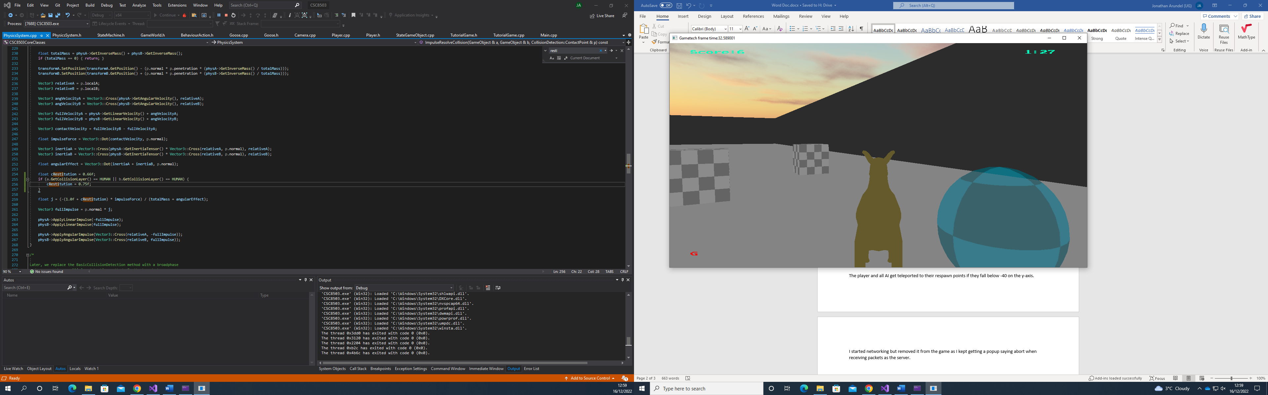

Humans have a higher coefficient of restitution with other objects making them bouncier than other entities in the scene.

The player and all AI get teleported to their respawn points if they fall below -40 on the y-axis.

I started networking but removed it from the game as I kept getting a popup saying abort when receiving packets as the server.